**PL/SQL PROGRAMMING**

**Exercise 1: Control Structures**

**Scenario 1:** The bank wants to apply a discount to loan interest rates for customers above 60 years old.

* + **Question:** Write a PL/SQL block that loops through all customers, checks their age, and if they are above 60, apply a 1% discount to their current loan interest rates.

**QUERY:**

BEGIN

FOR rec IN (

SELECT l.LoanID, c.DOB

FROM Loans l

JOIN Customers c ON l.CustomerID = c.CustomerID

) LOOP

IF MONTHS_BETWEEN(SYSDATE, rec.DOB) / 12 > 60 THEN

UPDATE Loans SET InterestRate = InterestRate - 1

WHERE LoanID = rec.LoanID;

END IF;

END LOOP;

END;

/

**OUTPUT**

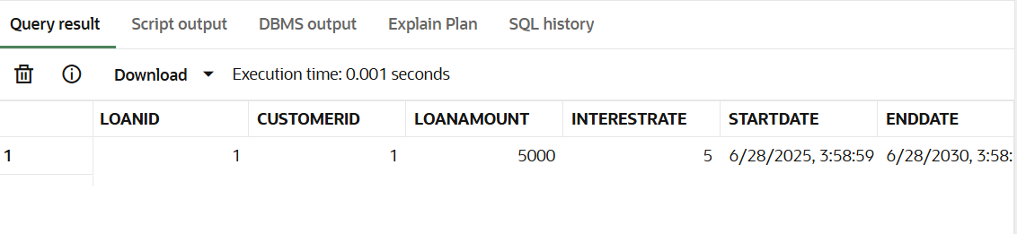

**Scenario 2:** A customer can be promoted to VIP status based on their balance.

**Question:** Write a PL/SQL block that iterates through all customers and sets a flag IsVIP to TRUE for those with a balance over $10,000.

**QUERY**

ALTER TABLE Customers ADD IsVIP CHAR(1);

BEGIN

FOR rec IN (SELECT * FROM Customers) LOOP

IF rec.Balance > 10000 THEN

UPDATE Customers SET IsVIP = 'Y' WHERE CustomerID = rec.CustomerID;

END IF;

END LOOP;

END;

/

SELECT Name, Balance, IsVIP FROM Customers;

**OUTPUT**

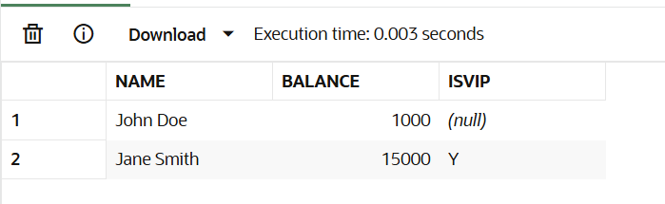

**Scenario 3:** The bank wants to send reminders to customers whose loans are due within the next 30 days.

* + **Question:** Write a PL/SQL block that fetches all loans due in the next 30 days and prints a reminder message for each customer.

**QUERY**

INSERT INTO Loans VALUES (3, 1, 3000, 6, SYSDATE, SYSDATE + 5);

COMMIT;

BEGIN

FOR rec IN (SELECT * FROM Loans WHERE EndDate <= SYSDATE + 30) LOOP

DBMS_OUTPUT.PUT_LINE('Reminder: Loan ID ' || rec.LoanID || ' is due soon.');

END LOOP;

END;

/

**OUTPUT**

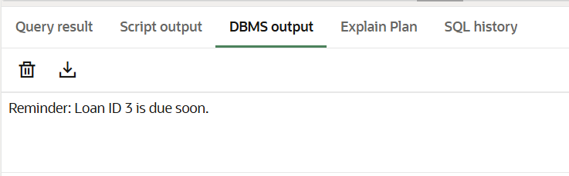

**Exercise 2: Error Handling**

**Scenario 1:** Handle exceptions during fund transfers between accounts.

* + **Question:** Write a stored procedure SafeTransferFunds that transfers funds between two accounts. Ensure that if any error occurs (e.g., insufficient funds), an appropriate error message is logged and the transaction is rolled back.

**QUERY**

CREATE OR REPLACE PROCEDURE SafeTransferFunds(

p_from_account_id IN NUMBER,

p_to_account_id IN NUMBER,

p_amount IN NUMBER

) AS

v_balance NUMBER;

BEGIN

-- Lock the source account row for update

SELECT Balance INTO v_balance FROM Accounts

WHERE AccountID = p_from_account_id FOR UPDATE;

IF v_balance < p_amount THEN

RAISE_APPLICATION_ERROR(-20001, 'Insufficient funds.');

END IF;

UPDATE Accounts SET Balance = Balance - p_amount WHERE AccountID = p_from_account_id;

UPDATE Accounts SET Balance = Balance + p_amount WHERE AccountID = p_to_account_id;

DBMS_OUTPUT.PUT_LINE('Transfer successful.');

COMMIT;

EXCEPTION

WHEN OTHERS THEN

DBMS_OUTPUT.PUT_LINE('Transfer failed: ' || SQLERRM);

ROLLBACK;

END;

/

BEGIN

SafeTransferFunds(1, 2, 500);

END;

/

**OUTPUT**



BEGIN

SafeTransferFunds(1, 2, 100000); -- should fail

END;

/

**OUTPUT** (if transfer amount is more than balance)

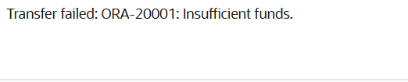

**Scenario 2:** Manage errors when updating employee salaries.

* + **Question:** Write a stored procedure UpdateSalary that increases the salary of an employee by a given percentage. If the employee ID does not exist, handle the exception and log an error message.

**OUERY**

CREATE OR REPLACE PROCEDURE UpdateSalary(

p_emp_id IN NUMBER,

p_percent IN NUMBER

) AS

BEGIN

UPDATE Employees

SET Salary = Salary + (Salary * p_percent / 100)

WHERE EmployeeID = p_emp_id;

IF SQL%ROWCOUNT = 0 THEN

RAISE_APPLICATION_ERROR(-20002, 'Employee not found.');

ELSE

DBMS_OUTPUT.PUT_LINE('Salary updated successfully.');

END IF;

COMMIT;

EXCEPTION

WHEN OTHERS THEN

DBMS_OUTPUT.PUT_LINE('Error: ' || SQLERRM);

ROLLBACK;

END;

/

BEGIN

UpdateSalary(1, 10); -- increase 10%

END;

/

**OUTPUT**



BEGIN

UpdateSalary(99, 5); --INVALID ID

END;

/

**OUTPUT**

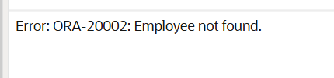

**Scenario 3:** Ensure data integrity when adding a new customer.

* + **Question:** Write a stored procedure AddNewCustomer that inserts a new customer into the Customers table. If a customer with the same ID already exists, handle the exception by logging an error and preventing the insertion.

**QUERY**

CREATE OR REPLACE PROCEDURE AddNewCustomer(

  p_id      IN NUMBER,

  p_name    IN VARCHAR2,

  p_dob     IN DATE,

  p_balance IN NUMBER

) AS

BEGIN

  INSERT INTO Customers (CustomerID, Name, DOB, Balance, LastModified)

  VALUES (p_id, p_name, p_dob, p_balance, SYSDATE);

  DBMS_OUTPUT.PUT_LINE('Customer added successfully.');

  COMMIT;

EXCEPTION

  WHEN DUP_VAL_ON_INDEX THEN

    DBMS_OUTPUT.PUT_LINE('Error: Customer ID already exists.');

  WHEN OTHERS THEN

    DBMS_OUTPUT.PUT_LINE('Unexpected error: ' || SQLERRM);

    ROLLBACK;

END;

/

BEGIN

  AddNewCustomer(3, 'New Customer', TO_DATE('2000-01-01','YYYY-MM-DD'), 2000);

END;

/

**OUTPUT**



BEGIN

  AddNewCustomer(3, 'Duplicate', TO_DATE('1999-01-01','YYYY-MM-DD'), 1000); -- Try adding same ID again

END;

/

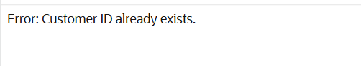

**Exercise 3: Stored Procedures**

**Scenario 1:** The bank needs to process monthly interest for all savings accounts.

* + **Question:** Write a stored procedure **ProcessMonthlyInterest** that calculates and updates the balance of all savings accounts by applying an interest rate of 1% to the current balance.

**QUERY**

CREATE OR REPLACE PROCEDURE ProcessMonthlyInterest IS

BEGIN

  FOR acc IN (

    SELECT AccountID, Balance

    FROM Accounts

    WHERE AccountType = 'Savings'

  ) LOOP

    UPDATE Accounts

    SET Balance = acc.Balance + (acc.Balance * 0.01)

    WHERE AccountID = acc.AccountID;

    DBMS_OUTPUT.PUT_LINE('Interest added to Account ID: ' || acc.AccountID);

  END LOOP;

  COMMIT;

END;

/

BEGIN

  ProcessMonthlyInterest;

END;

/

**OUTPUT**



**Scenario 2:** The bank wants to implement a bonus scheme for employees based on their performance.

* + Question: Write a stored procedure UpdateEmployeeBonus that updates the salary of employees in a given department by adding a bonus percentage passed as a parameter.

**QUERY**

CREATE OR REPLACE PROCEDURE UpdateEmployeeBonus(

  p_department IN VARCHAR2,

  p_bonus_pct IN NUMBER

) IS

BEGIN

  FOR emp IN (

    SELECT EmployeeID, Salary FROM Employees WHERE Department = p_department

  ) LOOP

    UPDATE Employees

    SET Salary = emp.Salary + (emp.Salary * p_bonus_pct / 100)

    WHERE EmployeeID = emp.EmployeeID;

    DBMS_OUTPUT.PUT_LINE('Bonus updated for Employee ID: ' || emp.EmployeeID);

  END LOOP;

  COMMIT;

END;

/

BEGIN

  UpdateEmployeeBonus('IT', 5);  -- Apply 5% bonus to IT department

END;

/

**OUTPUT**

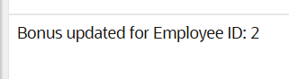

**Scenario 3:** Customers should be able to transfer funds between their accounts.

* + **Question:** Write a stored procedure TransferFunds that transfers a specified amount from one account to another, checking that the source account has sufficient balance before making the transfer.

**QUERY**

CREATE OR REPLACE PROCEDURE TransferFunds(

  p_from_account_id IN NUMBER,

  p_to_account_id   IN NUMBER,

  p_amount          IN NUMBER

) AS

  v_balance NUMBER;

BEGIN

  -- Get balance of source account

  SELECT Balance INTO v_balance FROM Accounts

  WHERE AccountID = p_from_account_id FOR UPDATE;

  IF v_balance < p_amount THEN

    DBMS_OUTPUT.PUT_LINE('Error: Insufficient funds.');

    ROLLBACK;

    RETURN;

  END IF;

  -- Perform the fund transfer

  UPDATE Accounts SET Balance = Balance - p_amount

  WHERE AccountID = p_from_account_id;

  UPDATE Accounts SET Balance = Balance + p_amount

  WHERE AccountID = p_to_account_id;

  DBMS_OUTPUT.PUT_LINE('Transfer of ' || p_amount || ' completed successfully.');

  COMMIT;

EXCEPTION

  WHEN NO_DATA_FOUND THEN

    DBMS_OUTPUT.PUT_LINE('Error: One of the account IDs does not exist.');

    ROLLBACK;

  WHEN OTHERS THEN

    DBMS_OUTPUT.PUT_LINE('Unexpected error: ' || SQLERRM);

    ROLLBACK;

END;

/

BEGIN

  TransferFunds(1, 2, 100);

END;

/

**OUTPUT**

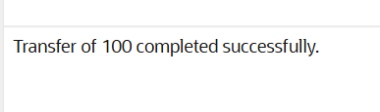

**Exercise 4: Functions**

**Scenario 1:** Calculate the age of customers for eligibility checks.

**Question:** Write a function CalculateAge that takes a customer's date of birth as input and returns their age in years.

**QUERY**

CREATE OR REPLACE FUNCTION CalculateAge(p_dob DATE)

RETURN NUMBER IS

  v_age NUMBER;

BEGIN

  v_age := TRUNC(MONTHS_BETWEEN(SYSDATE, p_dob) / 12);

  RETURN v_age;

END;

/

SELECT Name, DOB, CalculateAge(DOB) AS Age

FROM Customers;

**OUTPUT**

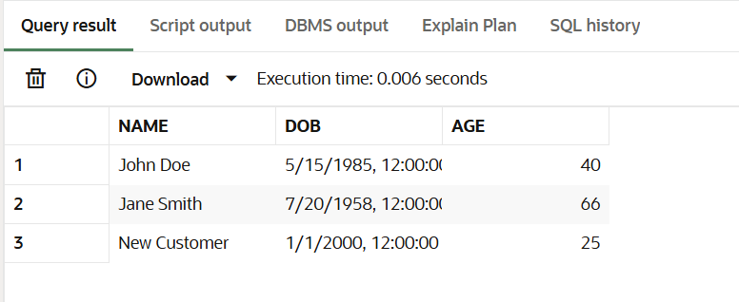

**Scenario 2:** The bank needs to compute the monthly installment for a loan.

* + **Question:** Write a function CalculateMonthlyInstallment that takes the loan amount, interest rate, and loan duration in years as input and returns the monthly installment amount.

**QUERY**

CREATE OR REPLACE FUNCTION CalculateMonthlyInstallment(

p_loan_amount NUMBER,

p_annual_rate NUMBER,

p_duration_years NUMBER

) RETURN NUMBER IS

v_monthly_rate NUMBER := p_annual_rate / 12 / 100;

v_months NUMBER := p_duration_years * 12;

v_emi NUMBER;

BEGIN

IF v_monthly_rate = 0 THEN

v_emi := p_loan_amount / v_months;

ELSE

v_emi := (p_loan_amount * v_monthly_rate * POWER(1 + v_monthly_rate, v_months)) /

(POWER(1 + v_monthly_rate, v_months) - 1);

END IF;

RETURN ROUND(v_emi, 2);

END;

/

SELECT CalculateMonthlyInstallment(100000, 6, 5) AS EMI FROM dual;

**OUTPUT**

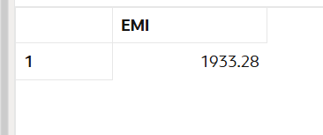

**Scenario 3:** Check if a customer has sufficient balance before making a transaction.

* + **Question:** Write a function **HasSufficientBalance** that takes an account ID and an amount as input and returns a boolean indicating whether the account has at least the specified amount.

**QUERY**

 p_account_id NUMBER,

  p_amount     NUMBER

) RETURN BOOLEAN IS

  v_balance NUMBER;

BEGIN

  SELECT Balance INTO v_balance FROM Accounts WHERE AccountID = p_account_id;

  RETURN v_balance >= p_amount;

EXCEPTION

  WHEN NO_DATA_FOUND THEN

    RETURN FALSE;

END;

/

DECLARE

  v_result BOOLEAN;

BEGIN

  v_result := HasSufficientBalance(1, 500);  -- Change values as needed

  IF v_result THEN

    DBMS_OUTPUT.PUT_LINE('Sufficient balance.');

  ELSE

    DBMS_OUTPUT.PUT_LINE('Insufficient balance or account not found.');

  END IF;

END;

/

**OUTPUT**

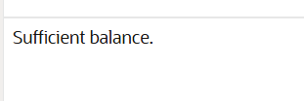

**Exercise 5: Triggers**

**Scenario 1:** Automatically update the last modified date when a customer's record is updated.

* + **Question:** Write a trigger UpdateCustomerLastModified that updates the LastModified column of the Customers table to the current date whenever a customer's record is updated.

**QUERY**

CREATE OR REPLACE TRIGGER UpdateCustomerLastModified

BEFORE UPDATE ON Customers

FOR EACH ROW

BEGIN

  :NEW.LastModified := SYSDATE;

END;

/

UPDATE Customers

SET Balance = Balance + 100

WHERE CustomerID = 1;

SELECT Name, Balance, LastModified FROM Customers WHERE CustomerID = 1;

**OUTPUT**

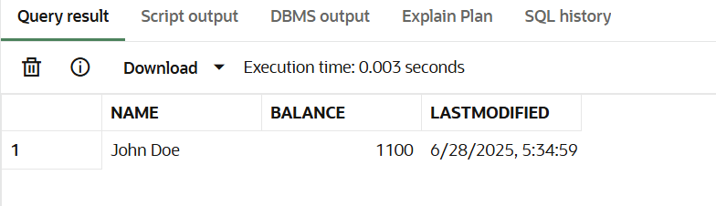

**Scenario 2:** Maintain an audit log for all transactions.

* + **Question:** Write a trigger LogTransaction that inserts a record into an AuditLog table whenever a transaction is inserted into the Transactions table.

**QUERY**

CREATE TABLE AuditLog (

  LogID NUMBER GENERATED ALWAYS AS IDENTITY PRIMARY KEY,

  TransactionID NUMBER,

  AccountID NUMBER,

  Amount NUMBER,

  TransactionType VARCHAR2(10),

  LogDate DATE

);

CREATE OR REPLACE TRIGGER LogTransaction

AFTER INSERT ON Transactions

FOR EACH ROW

BEGIN

  INSERT INTO AuditLog (TransactionID, AccountID, Amount, TransactionType, LogDate)

  VALUES (:NEW.TransactionID, :NEW.AccountID, :NEW.Amount, :NEW.TransactionType, SYSDATE);

END;

/

-- Insert a transaction

INSERT INTO Transactions (TransactionID, AccountID, TransactionDate, Amount, TransactionType)

VALUES (3, 1, SYSDATE, 250, 'Deposit');

-- View audit log

SELECT * FROM AuditLog WHERE TransactionID = 3;

**OUTPUT**

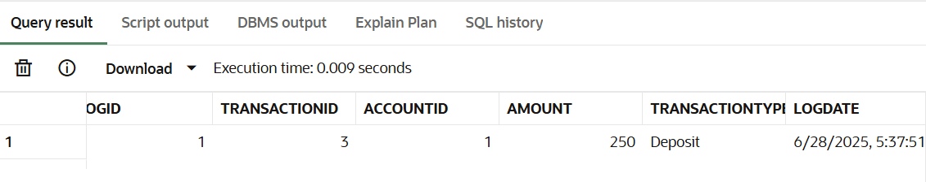

**Scenario 3:** Enforce business rules on deposits and withdrawals.

* + **Question:** Write a trigger CheckTransactionRules that ensures withdrawals do not exceed the balance and deposits are positive before inserting a record into the Transactions table.

**QUERY**

CREATE OR REPLACE TRIGGER CheckTransactionRules

BEFORE INSERT ON Transactions

FOR EACH ROW

DECLARE

  v_balance NUMBER;

BEGIN

  IF :NEW.TransactionType = 'Withdrawal' THEN

    SELECT Balance INTO v_balance FROM Accounts WHERE AccountID = :NEW.AccountID;

    IF :NEW.Amount > v_balance THEN

      RAISE_APPLICATION_ERROR(-20001, 'Insufficient balance for withdrawal.');

    END IF;

  ELSIF :NEW.TransactionType = 'Deposit' THEN

    IF :NEW.Amount <= 0 THEN

      RAISE_APPLICATION_ERROR(-20002, 'Deposit amount must be positive.');

    END IF;

  END IF;

END;

/

-- Account 2 has only 300, try withdrawing 1000

INSERT INTO Transactions (TransactionID, AccountID, TransactionDate, Amount, TransactionType)

VALUES (4, 2, SYSDATE, 1000, 'Withdrawal');

**OUTPUT**



**---INVALID DEPOSIT--**

INSERT INTO Transactions (TransactionID, AccountID, TransactionDate, Amount, TransactionType)

VALUES (5, 1, SYSDATE, -100, 'Deposit');

**OUTPUT**



--VALID TRANSACTION—

INSERT INTO Transactions (TransactionID, AccountID, TransactionDate, Amount, TransactionType)

VALUES (6, 1, SYSDATE, 200, 'Deposit');

SELECT * FROM Transactions WHERE TransactionID = 6;

**OUTPUT**

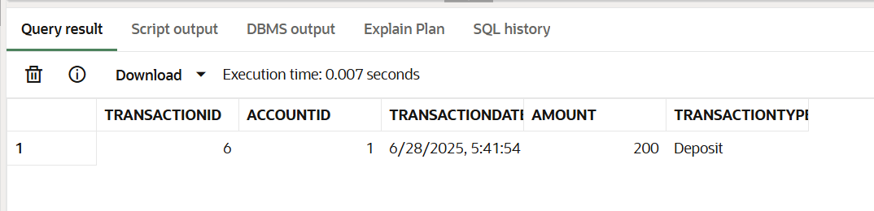

**Exercise 6: Cursors**

**Scenario 1:** Generate monthly statements for all customers.

* + **Question:** Write a PL/SQL block using an explicit cursor GenerateMonthlyStatements that retrieves all transactions for the current month and prints a statement for each customer.

**QUERY**

DECLARE

  CURSOR cur_transactions IS

    SELECT t.AccountID, c.Name, t.Amount, t.TransactionDate, t.TransactionType

    FROM Transactions t

    JOIN Accounts a ON t.AccountID = a.AccountID

    JOIN Customers c ON a.CustomerID = c.CustomerID

    WHERE TRUNC(t.TransactionDate, 'MM') = TRUNC(SYSDATE, 'MM');

  v_account_id Transactions.AccountID%TYPE;

  v_name Customers.Name%TYPE;

  v_amount Transactions.Amount%TYPE;

  v_date Transactions.TransactionDate%TYPE;

  v_type Transactions.TransactionType%TYPE;

BEGIN

  OPEN cur_transactions;

  LOOP

    FETCH cur_transactions INTO v_account_id, v_name, v_amount, v_date, v_type;

    EXIT WHEN cur_transactions%NOTFOUND;

    DBMS_OUTPUT.PUT_LINE('Customer: ' || v_name ||

                         ' | Account: ' || v_account_id ||

                         ' | Date: ' || TO_CHAR(v_date, 'DD-MON') ||

                         ' | Amount: ' || v_amount ||

                         ' | Type: ' || v_type);

  END LOOP;

  CLOSE cur_transactions;

END;

/

**OUTPUT**

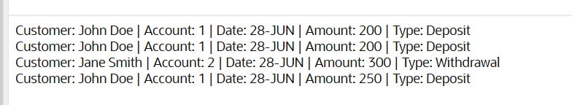

**Scenario 2:** Apply annual fee to all accounts.

* + **Question:** Write a PL/SQL block using an explicit cursor ApplyAnnualFee that deducts an annual maintenance fee from the balance of all accounts.

**QUERY**

DECLARE

CURSOR cur_accounts IS

SELECT AccountID, Balance FROM Accounts;

v_account_id Accounts.AccountID%TYPE;

v_balance Accounts.Balance%TYPE;

v_fee CONSTANT NUMBER := 100;

BEGIN

OPEN cur_accounts;

LOOP

FETCH cur_accounts INTO v_account_id, v_balance;

EXIT WHEN cur_accounts%NOTFOUND;

UPDATE Accounts

SET Balance = Balance - v_fee

WHERE AccountID = v_account_id;

DBMS_OUTPUT.PUT_LINE('Annual fee of ' || v_fee ||

' applied to Account ID: ' || v_account_id);

END LOOP;

CLOSE cur_accounts;

COMMIT;

END;

/

**OUTPUT**



**Scenario 3:** Update the interest rate for all loans based on a new policy.

* + **Question:** Write a PL/SQL block using an explicit cursor UpdateLoanInterestRates that fetches all loans and updates their interest rates based on the new policy.

**QUERY**

DECLARE

CURSOR cur_loans IS

SELECT LoanID, LoanAmount, InterestRate FROM Loans;

v_loan_id Loans.LoanID%TYPE;

v_amount Loans.LoanAmount%TYPE;

v_rate Loans.InterestRate%TYPE;

BEGIN

OPEN cur_loans;

LOOP

FETCH cur_loans INTO v_loan_id, v_amount, v_rate;

EXIT WHEN cur_loans%NOTFOUND;

IF v_amount > 7000 THEN

UPDATE Loans

SET InterestRate = v_rate + 0.5

WHERE LoanID = v_loan_id;

DBMS_OUTPUT.PUT_LINE('Updated interest for Loan ID: ' || v_loan_id);

ELSE

DBMS_OUTPUT.PUT_LINE('No update needed for Loan ID: ' || v_loan_id);

END IF;

END LOOP;

CLOSE cur_loans;

COMMIT;

END;

/

**OUTPUT**

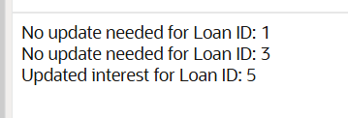

**Exercise 7: Packages**

**Scenario 1:** Group all customer-related procedures and functions into a package.

* + **Question:** Create a package CustomerManagement with procedures for adding a new customer, updating customer details, and a function to get customer balance.

**QUERY**

CREATE OR REPLACE PACKAGE CustomerManagement AS

  PROCEDURE AddCustomer(p_id NUMBER, p_name VARCHAR2, p_dob DATE, p_balance NUMBER);

  PROCEDURE UpdateCustomer(p_id NUMBER, p_balance NUMBER);

  FUNCTION GetCustomerBalance(p_id NUMBER) RETURN NUMBER;

END CustomerManagement;

/

CREATE OR REPLACE PACKAGE BODY CustomerManagement AS

  PROCEDURE AddCustomer(p_id NUMBER, p_name VARCHAR2, p_dob DATE, p_balance NUMBER) IS

  BEGIN

    INSERT INTO Customers (CustomerID, Name, DOB, Balance, LastModified)

    VALUES (p_id, p_name, p_dob, p_balance, SYSDATE);

    DBMS_OUTPUT.PUT_LINE('Customer added.');

  EXCEPTION

    WHEN DUP_VAL_ON_INDEX THEN

      DBMS_OUTPUT.PUT_LINE('Customer already exists.');

  END;

  PROCEDURE UpdateCustomer(p_id NUMBER, p_balance NUMBER) IS

  BEGIN

    UPDATE Customers SET Balance = p_balance, LastModified = SYSDATE WHERE CustomerID = p_id;

    DBMS_OUTPUT.PUT_LINE('Customer updated.');

  END;

  FUNCTION GetCustomerBalance(p_id NUMBER) RETURN NUMBER IS

    v_balance NUMBER;

  BEGIN

    SELECT Balance INTO v_balance FROM Customers WHERE CustomerID = p_id;

    RETURN v_balance;

  EXCEPTION

    WHEN NO_DATA_FOUND THEN

      RETURN NULL;

  END;

END CustomerManagement;

/

BEGIN

  CustomerManagement.AddCustomer(3, 'Arun Kumar', TO_DATE('2000-01-01', 'YYYY-MM-DD'), 2000);

  CustomerManagement.UpdateCustomer(3, 2500);

  DBMS_OUTPUT.PUT_LINE('Balance: ' || CustomerManagement.GetCustomerBalance(3));

END;

/

**OUTPUT**

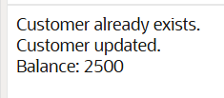

**Scenario 2:** Create a package to manage employee data.

* + **Question:** Write a package EmployeeManagement with procedures to hire new employees, update employee details, and a function to calculate annual salary.

**QUERY**

CREATE OR REPLACE PACKAGE EmployeeManagement AS

  PROCEDURE HireEmployee(p_id NUMBER, p_name VARCHAR2, p_position VARCHAR2, p_salary NUMBER, p_dept VARCHAR2);

  PROCEDURE UpdateEmployee(p_id NUMBER, p_salary NUMBER);

  FUNCTION GetAnnualSalary(p_id NUMBER) RETURN NUMBER;

END EmployeeManagement;

/

CREATE OR REPLACE PACKAGE BODY EmployeeManagement AS

  PROCEDURE HireEmployee(p_id NUMBER, p_name VARCHAR2, p_position VARCHAR2, p_salary NUMBER, p_dept VARCHAR2) IS

  BEGIN

    INSERT INTO Employees (EmployeeID, Name, Position, Salary, Department, HireDate)

    VALUES (p_id, p_name, p_position, p_salary, p_dept, SYSDATE);

    DBMS_OUTPUT.PUT_LINE('Employee hired.');

  END;

  PROCEDURE UpdateEmployee(p_id NUMBER, p_salary NUMBER) IS

  BEGIN

    UPDATE Employees SET Salary = p_salary WHERE EmployeeID = p_id;

    DBMS_OUTPUT.PUT_LINE('Employee salary updated.');

  END;

  FUNCTION GetAnnualSalary(p_id NUMBER) RETURN NUMBER IS

    v_salary NUMBER;

  BEGIN

    SELECT Salary INTO v_salary FROM Employees WHERE EmployeeID = p_id;

    RETURN v_salary * 12;

  EXCEPTION

    WHEN NO_DATA_FOUND THEN

      RETURN NULL;

  END;

END EmployeeManagement;

/

BEGIN

  EmployeeManagement.HireEmployee(3, 'Ravi', 'Analyst', 50000, 'Finance');

  EmployeeManagement.UpdateEmployee(3, 55000);

  DBMS_OUTPUT.PUT_LINE('Annual Salary: ' || EmployeeManagement.GetAnnualSalary(3));

END;

/

**OUTPUT**



**Scenario 3:** Group all account-related operations into a package.

* + **Question:** Create a package AccountOperations with procedures for opening a new account, closing an account, and a function to get the total balance of a customer across all accounts.

**QUERY**

CREATE OR REPLACE PACKAGE AccountOperations AS

  PROCEDURE OpenAccount(p_acc_id NUMBER, p_cust_id NUMBER, p_type VARCHAR2, p_balance NUMBER);

  PROCEDURE CloseAccount(p_acc_id NUMBER);

  FUNCTION GetTotalBalance(p_cust_id NUMBER) RETURN NUMBER;

END AccountOperations;

/

CREATE OR REPLACE PACKAGE BODY AccountOperations AS

  PROCEDURE OpenAccount(p_acc_id NUMBER, p_cust_id NUMBER, p_type VARCHAR2, p_balance NUMBER) IS

  BEGIN

    INSERT INTO Accounts (AccountID, CustomerID, AccountType, Balance, LastModified)

    VALUES (p_acc_id, p_cust_id, p_type, p_balance, SYSDATE);

    DBMS_OUTPUT.PUT_LINE('Account opened.');

  END;

  PROCEDURE CloseAccount(p_acc_id NUMBER) IS

  BEGIN

    DELETE FROM Accounts WHERE AccountID = p_acc_id;

    DBMS_OUTPUT.PUT_LINE('Account closed.');

  END;

  FUNCTION GetTotalBalance(p_cust_id NUMBER) RETURN NUMBER IS

    v_total NUMBER;

  BEGIN

    SELECT SUM(Balance) INTO v_total FROM Accounts WHERE CustomerID = p_cust_id;

    RETURN NVL(v_total, 0);

  END;

END AccountOperations;

/

BEGIN

  AccountOperations.OpenAccount(3, 1, 'Savings', 5000);

  AccountOperations.CloseAccount(3);

  DBMS_OUTPUT.PUT_LINE('Total balance: ' || AccountOperations.GetTotalBalance(1));

END;

/

**OUTPUT**

